**DAILY ONLINE ACTIVITIES SUMMARY**

|  |  |  |  |  |  |  |  |  |
| --- | --- | --- | --- | --- | --- | --- | --- | --- |
| **Date:** | **26 May 2020** | | | | | **Name:** | **Asha Rudrappa Totagi** | |
| **Sem& Sec** | **6thsem& A sec** | | | | | **USN:** | **4AL17CS015** | |
| **Online Test Summary** | | | | | | | | |
| **Subject** | | **Computer Graphics And Visualization** | | | | | | |
| **Max. Marks** | | **30** | | **Score** | | | **24** | |
| **Certification Course Summary** | | | | | | | | |
| **Course** | **Career Edge – Knockdown the Lockdown** | | | | | | | |
| **Certificate Provider** | | | **TCSiON** | | **Duration** | | | **15 days** |
| **Coding Challenges** | | | | | | | | |
| **Problem Statement**  **Program 1:** Given an array A of size N where the array elements contain values from 1 to N with duplicates, the task is to find total number of subarrays which start and end with the same element. | | | | | | | | |
| **Status: DONE** | | | | | | | | |
| **Uploaded the report in Github** | | | | | **YES** | | | |
| **If yes Repository name** | | | | | **Daily Status** | | | |
| **Uploaded the report in slack** | | | | | **YES** | | | |

Online Test Details: (Attach the snapshot and briefly write the report for the same)

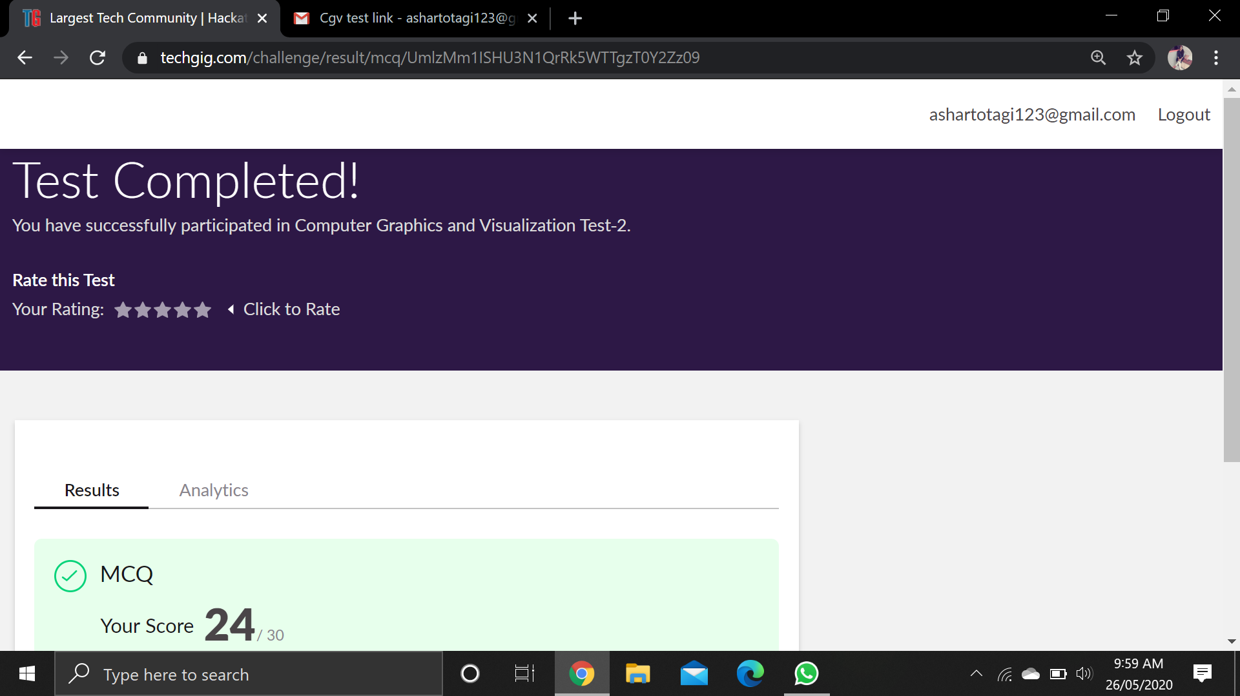

CGV IA test was held today i.e, 26 May 2020. Out of 30 marks I scored 24.

Certification Course Details: (Attach the snapshot and briefly write the report for the same

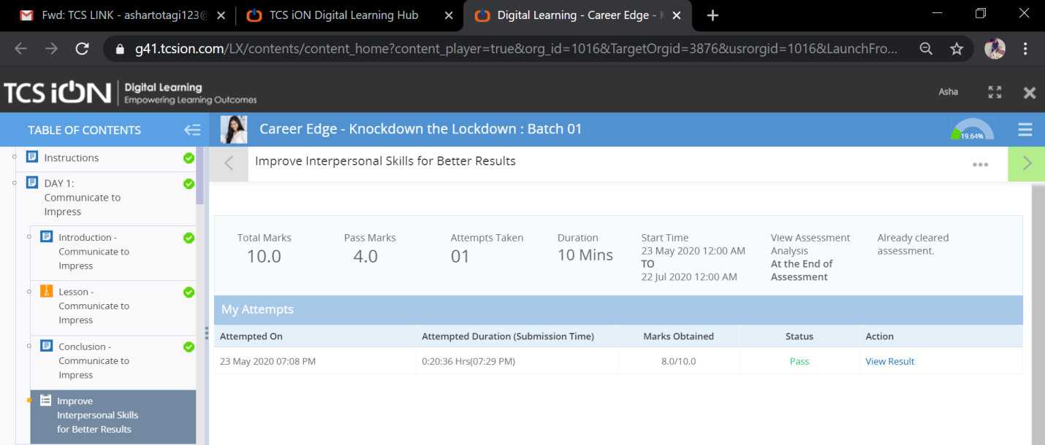

DAY1 (26-05-2020) – Communicate To Impress

Coding Challenges Details: (Attach the snapshot and briefly write the report for the same)

Program 1:

**public** **class** Main {

    // function to find total sub-array

    // which start and end with same element

**public** **static** **void** cntArray(**int** A[], **int** N)

    {

        // initialize result with 0

**int** result = 0;

**for** (**int** i = 0; i < N; i++) {

            // all size 1 sub-array

            // is part of our result

            result++;

            // element at current index

**int** current_value = A[i];

**for** (**int** j = i + 1; j < N; j++) {

                // Check if A[j] = A[i]

                // increase result by 1

**if** (A[j] == current_value) {

                    result++;

                }

            }

        }

        // print the result

        System.out.println(result);

    }

    // Driver code

**public** **static** **void** main(String[] args)

    {

**int**[] A = { 1, 5, 6, 1, 9,

                    5, 8, 10, 8, 9 };

**int** N = A.length;

        cntArray(A, N);

    }

}